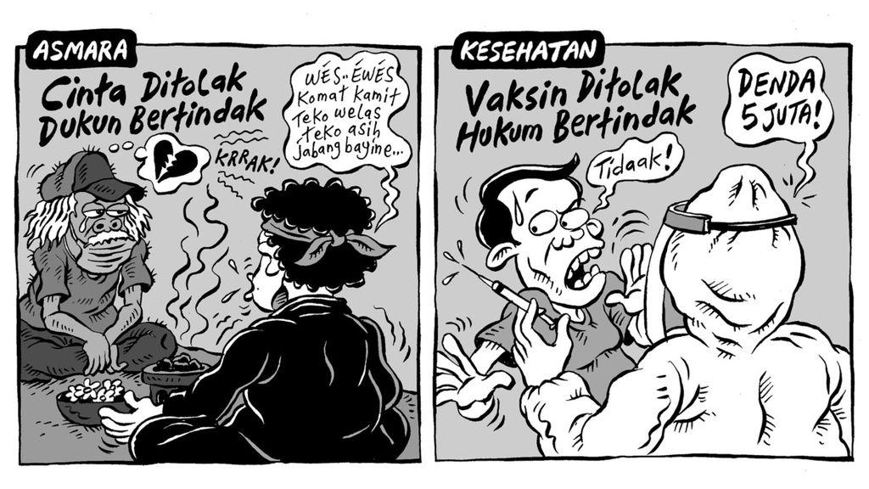

* Clara karya Seno Gumira Ajidarma